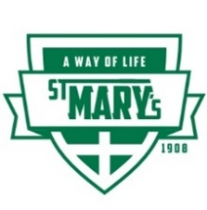
ST. MARY’S PARISH SCHOOL NEWSLETTER
for January 20, 2020

The Mission of St. Mary’s School is:
To Grow Disciples of Christ
Please read this information first:
Friday, January 24 is the end of the semester and school is closed. There will be childcare. Let the school know on/by Tuesday January 21 if you need childcare so we can plan for adequate coverage.
Saturday, January 25 is the 45th School Auction at Best Western Plus University Inn; doors open at 5:00 p.m. ALL are welcome to come to enjoy the event. Cost of entrance (with no dinner) is $10.00. Come and enjoy Under the Big Top Event.
Youth Book Club: January 26th open to Middle School readers; meeting monthly at the Monarch Hotel lobby from 4 to 6 p.m. Seely Johnson, Grade 6 is the leader. First book that will be read is: The Winter King by local author, Christine Cohen. Please RSVP seeleybird@me.com Snacks will be provided.
Monday, January 27 Moscow School District is closed--St. Mary's School is in session.
January 27 through 31st is Catholic Schools’ Week with a special theme per day, led by Student Council. See attached sheet for daily events. Parents are welcome to any and all events.
Safety Environment Workshop has been moved from this Saturday to Saturday, January 25 at 10:00 at the Parish Center. This workshop is required for all adults who work with children/youth.

DATES to note: __________

Monday, January 20: Legal Holiday---Martin Luther King Day--school is closed
Tuesday, January 21: Let school know by Tuesday January 21 if you need childcare on Friday, Jan. 24th so we can plan for adequate coverage.
Wednesday, January 22: NO Mass; Father Joe is in Boise this entire week. We will have the Installation of the Student Council officers at 8:45 a.m. in the lunchroom. (See below for names.) All are welcome.
Thursday, January 23: Debbie Johnson is out of the office Dec. 23-28.

Friday, January 24: No school; end of the semester—childcare is available.

Saturday, January 25: Auction at Best Western Plus University Inn; doors open at 5:00 p.m.—all are welcome

Sunday, January 26: Youth book club begins from 4 to 6:00 p.m. at the Monarch Motel lobby. Please RSVP by email to seeleybird@me.com See below for more information.

Wednesday, Jan. 22: since there is no Mass so the installation of the new Student Council Officers will take place at 8:45 a.m. in the lunchroom

PRESIDENT: Gianna Niehenke
VICE PRESIDENT: Katelyn Swam
SECRETARY; Anna Ristine
TREASURER: Wyatt Thornycroft
RELIGIOUS AFFAIRS: Sadie Newlan
SCHOOL SPIRIT: Hannah Johnson-Leung
PUBLIC RELATIONS: Anna Linskey
NATURAL HELPERS: Mason Poxleitner

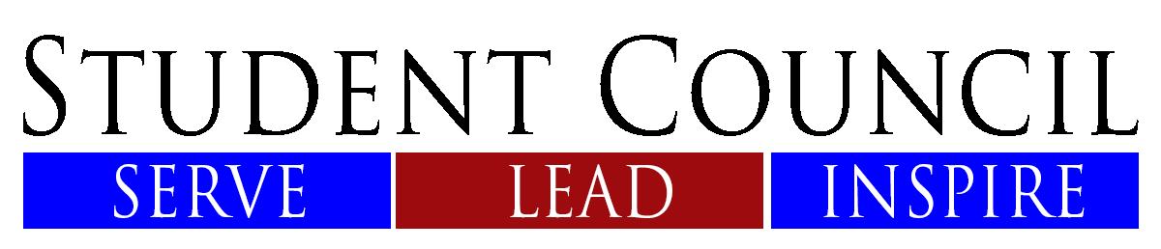

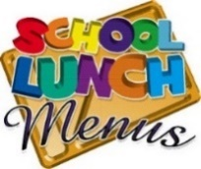
Monday, January 20 : No school
Tuesday, January 21: Mac n Cheese with ham; small sandwiches offered
Wednesday, January 22: Lil smokies in a biscuit Thursday, January 23: Corn dogs
Friday, January 24: No school
Daily we have choice of two fruits; various salads; veggies along with the main entrée; milk and water.

Reminder families whose picture is not on the wall, please send your picture via email to office@stmarysmoscow.com or bring a copy to the office. Thank you!

We are excited to announce a NEW YOUTH BOOK CLUB at the Monarch Motel hosted by Seely Johnson, a 6th grader at St. Mary’s Parish School. this book club is open to middle school readers and will meet once a month beginning January 26, 2020.
Our first meeting will be an opportunity to get to know each other, discuss our favorite reads and introduce our first book the Winter King by local author, Christine Cohen.
We will have snacks and most importantly fun! I hope you can join us in this new adventure this year! Please RSVP by email to seeleybird@me.com I look forward to seeing you on January 26th from 4 to 6 p.m. at the Monarch Motel lobby!

Nikki Crathorne has given us some great information about a way to assist the School Choir in raising funds to their Disney World Trip in June….
If you enjoy good food, the Garlic Garden Bistro Restaurant at 630 N. Almon St. #120 in Moscow (208-596-4659) is giving 10% of every order (carry-out or dine in) from now through June 6th. There is no limit how many times you participate. The only thing you must do for us to earn 10% donation is to mention St. Mary’s School choir fundraiser when you call/dine-in.

- January 27-31 is the celebration of “Catholic Schools Week”
- First Reconciliation January 31st at 7:00 p.m. at St. Mary’s Church.
- For those of you who are involved in ministry in St. Mary’s Parish (Eucharistic Ministers, Lectors, Altar Servers, Musicians, Hospitality, etc.) are invited (they and family) to an Appreciation Dinner. The dinner is on Saturday, February 1 at 6:30 p.m. at the Parish Center. Please RSVP to the parish office (208-882-4813) by January 27th.
- February 8/9 –Catholic Women’s League (CWL) will have a bake sale after all the Masses.
- February 15---dance at the Parish Center (all are welcome) with Jon Anderson and Rand Walker and their band. (CWL is sponsoring this dance)
- February 23---CWL’s meeting at 12:45 in the Parish Center—soup and bread will be served.
- CWL March 12: Paint and Sip Party

From Mr. Herrenbruck, PE Teacher….
We would like to thank the University of Idaho Movement Science Department and Dr. Phillip Scruggs for thinking of our school and supporting our students in their play!
We are grateful to them or donating three dozen gently used balls (basketballs, volleyballs, and soccer balls along with storage bags for them and many PE pennies. The balls will be used to replace older recess balls, as well as help build our PE supply of sporting balls and pennies.

Please note our ***“tagline” *** IGNITING faith, knowledge, creativity and service
is a statement about who we are and what is our focus here at St. Mary’s School.
You have and will continue to see this tagline on all school documents and
will start to see it in various ways around the school.
This does not replace our Mission Statement; rather it helps to emphasize who we are and
how we are living the Mission.

IGNITING faith, knowledge, creativity and service

