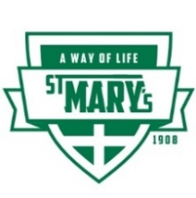
ST. MARY’S PARISH SCHOOL NEWSLETTER
for January 27, 2020

The Mission of St. Mary’s School is:
To Grow Disciples of Christ
Please read this information first:
Monday, January 27 Moscow School District is closed--St. Mary's School is in session.
Monday evening each student is invited to the U of I Men's Basketball game free. They received a voucher for the game at school on Friday.
January 27 through 31st is Catholic Schools’ Week with a special theme per day, led by Student Council. See attached sheet for daily events. Parents are welcome to any and all events.
January 31 Sacrament of Reconciliation is received for the first time by the children. The sacrament will be administered at 7:00 p.m. at St. Mary’s Church; reception follows.
February 1 at 6:30 p.m. is the Ministerial Appreciation Dinner for all ministers (EM, lectors, hospitality, etc.) and their families. Please call Pam by the 27th to RSVP at 208-882-4813.
Tuesday 4 at 6:00 p.m. School Board meeting
Wednesday, February 5 is Polar Walk to School Day.
Reminder about report cards you should receive them by January 31st. We have switched from one report card system to another and it is taking a little extra time to get them to you.
As we begin the 3rd quarter, we will start with celebrating National Catholic Schools Week, a celebration of Catholic education and an opportunity to share and recognize the importance, the values, and the contributions of Catholic education. The celebration is sponsored by the National Catholic Education Association of which we are a member. Your responses to the survey we sent to you last fall show that faith development, academic excellence, building community, service, and leadership development (major components of a Catholic education) are very important to you and your family.
Monday, January 27th is the Feast Day of St. Angela, the Foundress of the Ursuline Sisters of which Sister Margaret is a member. Our school was founded by Ursulines – it is wonderful to have the Ursuline charism ever present in our school. Thank you, Sister Margaret and all of your sisters who have come before!!!
What an exciting and wonderful evening we had last night for our 45th annual auction. Many thanks to Mr. Dan Bosse whose vision started the first auction. Due to illness he could not attend last night’s auction, it was fun to celebrate with Mr. and Mrs. Phil Mohan, who were parents of students in 1975. Also, deep gratitude to Dianna Spellman and her core team as well as everyone who worked before, during, and after to make last night such an incredibly wonderful evening. (See picture of the core group below.)
The question was asked, at the beginning of the auction, how many folks have attended the school auction for 20 years or more. It was amazing to witness the number of hands that were raised. Plus, it was so heart-warming to see such great generosity in support of the school’s mission. Definitely, a great time was had by all.
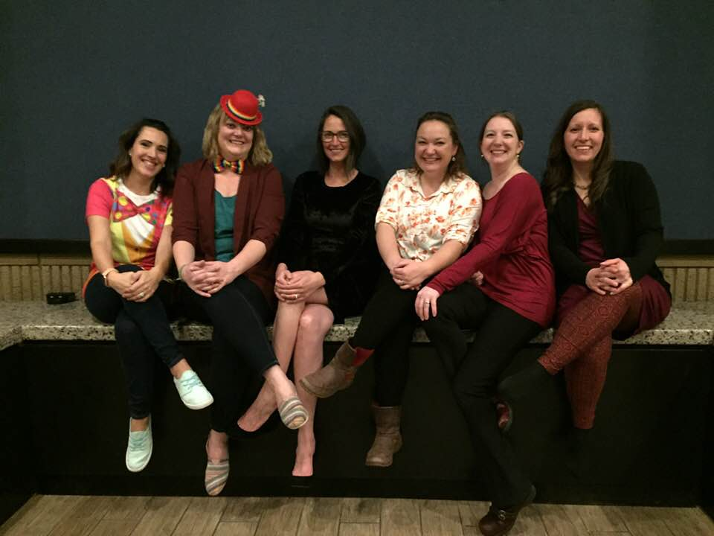

A huge thank you to the Auction Committee for ALL they did to provide a fabulous, fun time for all at our 45th Auction. AND a huge thank you to YOU, all the parents, for all the work you did by serving on the various committees: procurement, set-up, clean-up, etc. Your generosity and hard work have made a big difference in the auction this year. Blessings on all!
(Left to right: Deanna Spellman (chair), Jillann Poxleitner, Veronica Glienke, Joy Newlan, Danette Swam and Becky Couch)

To our new kindergarten family: Heidi and Joshua Evans and their daughter, Lillian, is coming today.

DATES to note: _________

Monday, January 27: – Twin Day and Service Day
Classes will also be taking an opportunity for community service. Drawing from the national theme of Catholic Schools Week, “Learn. Serve. Lead. Succeed” the student council wanted to serve some of our local community members. We will be making Valentine cards to be given to the local retirement homes and various other local charitable homes.
Today is also the feast of St. Angela Merici, Foundress of the Ursuline Sisters
who founded the school in 1908.

Tuesday, January 28 – Pajamas and Reading Day--Keeping in mind that during CSW we must still seek to learn, Student Council has chosen a special reading day; with a twist. We all get to spend the day in our PJ’s! All classes will be taking extra time out of their day do spend reading their favorite books and cuddling up in their cozy pajamas and slippers. There will also be some fun “buddy read time” where class buddies will get together to read with each other; a great opportunity for buddy leadership.
The Second Graders will be doing a bake sale for Heifer International at lunch time.

Wednesday, January 29 – Mass and Math Bowl--At St. Mary’s, we are “Igniting faith, knowledge, creativity, and service”, and as we do every week, we will express our faith at our weekly Mass. School Mass will begin at 9:00am at St. Mary’s Church and the Liturgy Leaders will be our Student Council leaders. However, students do not need to wear their school uniform on this Mass day. Why? Directly, following Mass, back at the school, our Kindergarten through 8th grade will be participating in our annual Math Bowl Competition. All students will be put onto one of two teams (red or blue team) by their teacher, and all students are encouraged to wear those colors to help support their Math Bowl team! All are welcome to come watch the competition and cheer on the students in the gym after Mass.

Thursday, January 30 – Crazy Hair or Hat Day and Family Feud
On this day, students get to let their creativity and spirit shine. Come to school with crazy hair or a crazy hat and enjoy seeing all your schoolmates’ crazy hairdos too! (*Reminder hair must be able to be back to normal the next day and nothing in the hair that will create a mess.
In the afternoon, starting at 2:00 pm in the lunchroom, Student Council will be hosting the game show Family Feud: Teachers vs Students! This friendly and competitive event is always a lot of fun to watch.
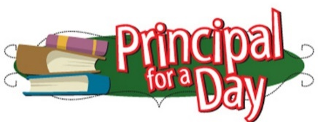
Each year at the Auction there is an item for Principal for a Day. Carl Stanton, Grade 8, is the Principal for a day on Thursday, January 30th. Congrats Principal Carl!

Friday, January 31 – Spirit Day and Movie/Game Day
On Friday, Student Council wants us to show our school spirit by wearing any St. Mary’s gear they may have retro or new, purchased or homemade, we want to show our St. Mary’s Lion’s pride. Each of the classes will be taking some time on this day to relax with a movie or games in their classrooms

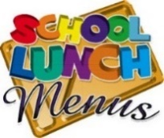
Monday, January 27: Bacon cheeseburger tater tots casserole
Tuesday, January 28: “Breakfast” with waffles + strawberries
Wednesday, January 29: Buttered noodles + corn + bacon
Thursday, January 30: Chicken nuggets + French Fries
Friday, January 31: Sausage McMuffin Casserole

Daily we have choice of two fruits; various salads;
veggies along with the main entrée; milk and water.

Information about the program IXL
Our students (grades 2, 6, 7 and 8) are involved in a computer program called IXL Our students really enjoy trying to improve their skills and continually work hard to doing problems. Recently we received word that our students in Grades 2, 6, 7 and 8 have cumulatively completed 150,000 questions! And they enjoy the challenge too!

There is a need for a few sew-ers to do the following:
Assist the parish in making “baptismal robes” for those coming into the church—quite simple to make and would take about an hour. If you can give the time, please call Caroline Canney at the parish office: 208- 882-4813. Thank you.
The second sewing need is to do some silk screening and sewing banners for the school. If you can do this, please call Sister Margaret at the school (208-882-2121). Thank you so much!

- February 8/9 –Catholic Women’s League (CWL) will have a bake sale after all the Masses.
- February 15---dance at the Parish Center (all are welcome) with Jon Anderson and Rand Walker and their band. (CWL is sponsoring this dance)
- February 23---CWL’s meeting at 12:45 in the Parish Center—soup and bread will be served.
- March 12: CWL Paint and Sip Party
Nikki Crathorne has given us some great information about a way to assist the School Choir in raising funds to their Disney World Trip in June….
If you enjoy good food, the Garlic Garden Bistro Restaurant at 630 N. Almon St. #120 in Moscow (208-596-4659) is giving 10% of every order (carry-out or dine in) from now through June 6th. There is no limit how many times you participate. The only thing you must do for us to earn 10% donation is to mention St. Mary’s School choir fundraiser when you call/dine-in.
NOTE about monthly calendars and hot lunch menu: this past month there was a computer glitch that took us some time to fix. Therefore, both were late in coming out. All is fixed and February’s calendar and hot lunch calendar will be sent out by the end of this week.

Do you ask your child “How was your day?” and the response is “good” or “ok” or “fine”? Here is a sheet of suggested questions you can ask of your child that might reveal more responses. See what you think? Questions are on the next page……

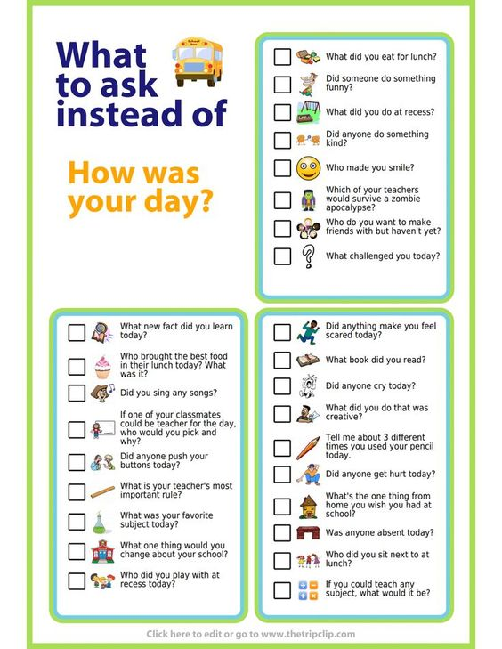

IGNITING faith, knowledge, creativity and service

