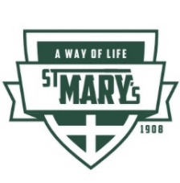
ST. MARY’S PARISH SCHOOL NEWSLETTER
for February 10, 2020

Our hope as we enter this week, is that everyone has had time to rest, catch up on sleep, get rid of the nasty bugs, and/or keep them at bay. The staff, plus one of our volunteers, worked most of Friday cleaning everything that could be thought of that was touched by anyone. It was amazing watching this team of people jump in, help each other, and find ways to efficiently clean with absolutely no complaints. It was also amazing to listen to their voices and see their faces. As crazy as it may sound, if you didn’t know they were hard at work cleaning and airing out the school, you would have thought they were working with each other to figure out different ways to teach and bring joy. Yes, at the end of their day they were exhausted and looked it. As I drove home, I reflected on the day and I was reminded of James chapter 1: “Consider it all joy when you encounter various trials, for you know that the testing of your faith produces perseverance.” Find joy in all things. It’s a matter of attitude that shapes how we approach difficult times in our day and helps us grow in perseverance and in faith. We are all very excited to come together again as a school community Tuesday morning – all bugs at bay – all joy to be found. Blessings.
DATES to note: _________________

Monday February 10 School is closed
Foundation Board meeting at 5:30 p.m. at the Parish Center.
Tuesday February 11 School re-opens.
School Board meeting at 6:00 p.m. at the school.
Wednesday February 12 Mass at 9:00 with the students. Due to Sandy Izzo’s recent sickness, the staff and students from Grade 3 will participate in the various parts of the Mass.
Thursday February 13 February 13 Spelling Bee at 1:00 in the band room---all are invited.
Friday February 14 Valentine parties in the classrooms in the afternoon
Saturday February 15 February 15---dance at the Parish Center (all are welcome) with Jon Anderson and Rand Walker and their band. (CWL is sponsoring this dance). NOTE: Dance is only for adults; there is no childcare for this event. Also, ALL adults are welcomed---and if you rather not dance, you don’t have to dance, just come and enjoy the music and one another. Snacks provided. BYOB (Bring your own beverage.) Cost? By donation only.
Sunday February 16
Monday February 17 NO school; no childcare due to Presidents’ Day (legal holiday)
Please save this date: Friday, March 6---the families of the school, RE and parish youth programs are responsible for bringing soup and bread before the Stations of the Cross. We are also responsible for being the leaders of prayer for the Stations. Thank you for putting this date on your calendars.

MATHCOUNTS
On Friday, February 7th, several of our middle grade students went to Lewiston to compete in Mathcounts. This is a national program that provides students in grades 6-8 the opportunity to compete in live, in-person contests against and alongside their peers. (It was founded in 1983).
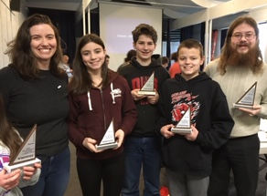
We have some great news to share with you! Parent-volunteer Jennifer Johnson-Leung put together a team of St. Mary's middle grades students to participate in our region's Math Counts chapter competition was held Friday, February 7 at Edge Ministries in Lewiston. Although Adrien Reineke-Quinlan was unable to attend, his classmates Ruby Claire Johnson-Leung (grade 7), Carl Stanton (grade 8), and Cameron Vogl (grade 8) competed and placed second. Ruby Claire even made it into the top 10 with her individual score. (There are 4 rounds, some as a team and some as individuals. You can learn more here: https://www.mathcounts.org/programs/competition-series.)

From left to right: Jennifer Johnson-Leung (parent volunteer)
Ruby Claire, Carl, Cameron and Jordan (assistant to Jennifer)
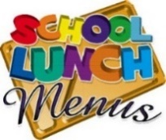
Monday February 10 School is closed
Tuesday February 11 Totcho Casserole (beans, hamburger, cheese, tater tots,)
Wednesday February 12 Quesadillas with cheese and/or meat
Thursday February 13 Breakfast Strata with ham and cheese casserole
Friday February 14 Baked Potato Bar

- February 23---CWL’s meeting after 11:30 a/m Mass at 12:45 in the Parish Center—soup and bread will be served.

- Monday, February 24 there will be the burning of palms at 1:00 at the school…all are welcome for this ritual.
Tuesday, February 25 there will be a special meeting for ALL parents to come and learn about the school finances, and budget/tuition for 2020-2021 school year. The meeting will begin at 6:30 p.m. at the school and will last about an hour. Childcare will be provided. Please put this on your calendars.

- March 12: CWL Paint and Sip Party
Nikki Crathorne has given us some great information about a way to assist the School Choir in raising funds to their Disney World Trip in June….
If you enjoy good food, the Garlic Garden Bistro Restaurant at 630 N. Almon St. #120 in Moscow (208-596-4659) is giving 10% of every order (carry-out or dine in) from now through June 6th. There is no limit how many times you participate. The only thing you must do for us to earn 10% donation is to mention St. Mary’s School choir fundraiser when you call/dine-in.

Stress in Your Marriage? – One week left to sign up for Retrouvaille. Retrouvaille is a program for married couples that feel bored, frustrated, or angry in their marriage. Some experience coldness and simply shut down. Others experience conflict and arguments in their relationship and don’t know how to change the situation or even communicate with their spouses about it. Retrouvaille is for any couple who would like to rediscover their marriage and improve communication. Visit www.Retrouvaille.org for emotional testimonials. For confidential information or to register for the February 14-16, 2020 Spokane weekend call (509) 520-4118 or (800) 470-2230 or visit the web site at www.Retrouvaille.org.
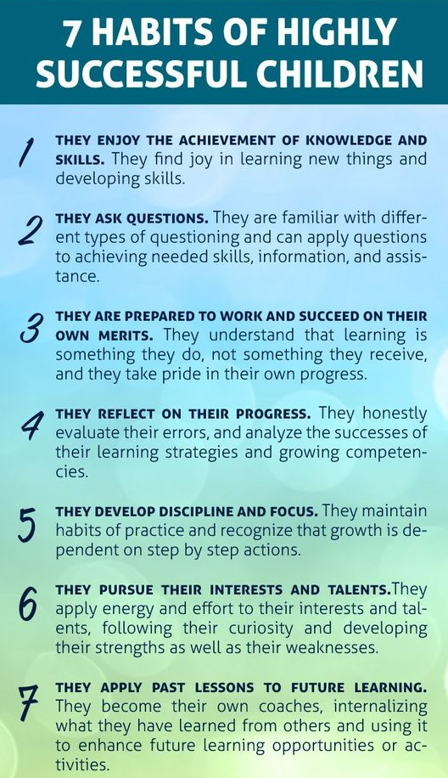

Also, attached is a handout:
77 Ways To Pray With Your Kids.

IGNITING faith, knowledge, creativity and service

