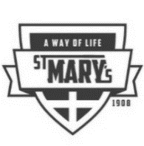
#13 NEWSLETTER for 2020-2021 School year
St. Mary’s Parish School
Week of Nov. 21, 2020

To all St Mary's families who donated a total of 56 boxes to Operation Christmas Child. This means so very much to children who struggle in our world.
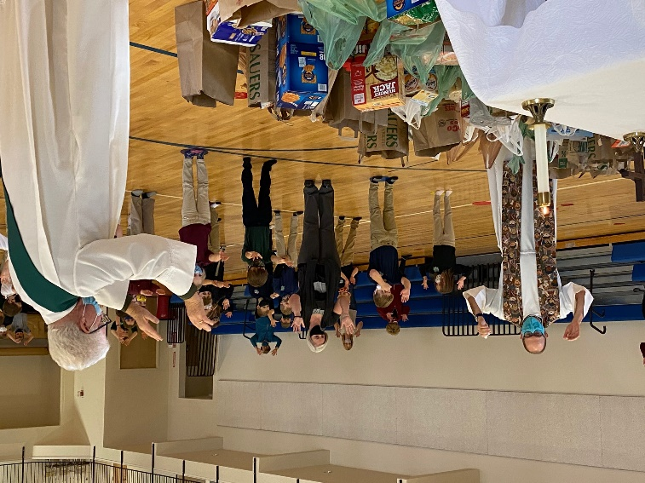
And thank you for your most generous donations of food to the Moscow Food Bank. Mrs. Nickles, head of the Food Bank, was so appreciative more than we ever had before and Mrs. Beller’s GMC Terrain car was filled to the brim except where she was sitting. Your donations will feed many, many families. Thank you!

All the food was blessed by Fr. Joe, Deacon George and the whole student body at the end of the Mass on Friday before it was taken to the Food Bank.

- St. Mary's Parish School is participating in the #iGiveCatholic Giving Day which takes place on Tuesday, December 3rd until Thursday, December 3rd. #iGiveCatholic is a global day for giving thanks. We want to make our participation in this program bigger and better. Why? There are so very many families in financial need desirous of a strong academic Christian education. As you know because of COVID, we've had to implement many improvements to keep our students and faculty safe which has been an unexpected expense and challenge. Your contributions of continued support would be very much appreciated and would go a lot farther in keeping everyone healthy and in school. Please consider donating to #iGiveCatholic. All monies donated come to the school. Thank you and you can give as early as now in the Pre-Giving Days that started on November 16th and run through November 30th. The link for your donations for Pre-Giving and Giving Tuesday, December 1st is: https://boise.igivecatholic.org/organizations/st-marys-catholic-school-moscow
B. Buying items from Amazon during this season? If yes, please click on Amazon Smile at Amazon website and name St. Mary's School Foundation of Moscow Idaho as the recipient for interest on all your purchases. Amazon gives a % to charities and our Foundation is one of them!

PICTURES….we would love to have a picture of your family—ESPECIALLY OUR NEW FAMILIES--to put on the wall. IF your family is missing from the wall (or you want to update last year’s photo), please send a picture via email to the school. Thank you!

Correction update to our Jog-a-thon results: Last week’s Newsletter gave the list of 40 students who brought in $250 plus. I inadvertently left off a name who ranked #26 with a total of $359.20. Congratulations to Kathryn Swam (Gr. 1) and my apologies for leaving her out of the list. We had a total of 41 students! Great job to all!!
From an interview by Dr. Thomas W. McGovern:
There are 3 W’s that, if we follow, will enable us to maintain a life that enables us to have our cherished activities (though not all). These are small acts that will pay great dividends for us. What are these 3 W’s?
- Wear a mask
- Wash your hands
- Watching our distances
AND there are 3 C’s that hold the highest risk factors which we must avoid. What are these 3 C’s?
- Closed spaces
- Crowded places
- Close contact settings.
Christmas Tree Sales begins the day after Thanksgiving. NOW is the time to sign up for tree sale shifts and a tree sale committee. Like last year, sign-ups will be maintained on-line through Google Docs. Please note the number of people required (on right side of good doc) for that time period and double check that the time slot is not already full. You will also need to make sure to sign-up for a committee as well. The committee signup is in the same Google Doc, so be sure to check the other tabs at the bottom. Due to Covid-19 this year, we are asking families to try and sign up for shifts with close family/friends that are inside of their “COVID bubbles” whenever possible. This would be mainly on the weekends when more people are needed. Please limit the time in the trailer with multiple people and wear a mask at all times. We want to make sure that we all remain safe and stay vigilant. Also, all must wear masks who work the Christmas tree lot. Thank you!
Here is the link:
https://docs.google.com/spreadsheets/d/1asqtySknnA9IFzvFIUtRy9kJqr1m63ZxeX2g5gArW2Q/edit?ts=5a04caf9#gid=0
When you sign up in google docs, there are multiple tabs to check:
1. Tree Shift Sign-ups (choose three shifts per family)
Choose One of below:
2. Set up the Lot Nov 24th
3. Unload Unwrap Nov 24th
4. Unload Unwrap Dec 5th
5. Unload Unwrap Dec 12th
6. Trailer Checker
7. Dismantle Lot
If you have trouble accessing this document please call Debbie Johnson in the school office at 208-882-2121.
REMINDER: Full participation in the Christmas Tree sale means working:
#1 THREE 2-hours shifts per family (due to our enrollment increase, we have shifted the responsibility from selling trees per child to per family) and
#2 Working on one of the committees (setting up trees, pricing trees, closing down the lot, etc.) The amount of committee time required is 4 hours (minimum) per family.

Buyouts for the tree sale include one or both of the following:
- I won’t be selling Christmas trees; bill my account $200.00 per child for tree sales and/or
- I won’t be working on a Christmas tree committee; bill my account $300.00 per family
When signing up for shifts, remember that the weekends, especially Saturdays from 12-6, are our busiest times, and we need to have people who are physically strong and able to load a lot of trees on those shifts.
The sooner you sign up; the more likely you are to get your desired time slots. When working at the lot, please remember to park your vehicles at the the west end of the lot and keep the closest spots available for TriState customers. Thank you so much for making our FUN Fundraiser Fun!
Items to note:

A yearly tradition we have had at St. Mary’s School is the Christmas Elves Workshop led by Student Council. Students are able to buy Christmas
gifts for family members. Monies from the sales are given to two local agencies that work with the neediest persons in our community: Family Promise of the Palouse and St. Vincent De Paul.
Needed for Elves Workshop: donations of items that students would like to buy as gifts for family members. Some examples are toys, stuffed animals, religious objects, jewelry, etc. Please send your items to the school as soon as possible.
Reminder: All students are to be in the new school uniform by January 2021.
Yearly Christmas Concert: Due to the COVID restrictions and the need to keep all safe and healthy per the 3 W’s (see above)---there won’t be a Christmas concert this year. It will return…..
Yearly Auction: Again, due to COVID restrictions and how our local businesses have been affected, the yearly auction is not able to happen this year. Yes, we will still need to raise funds for our operating budget. We have a fundraising committee of persons dedicated to creatively come up with ways to raise our needed funds. Stay tuned for information that will be coming after Thanksgiving.
Creator, open our hearts to peace and healing between all people. Creator, open our hearts to provide and protect for all children of the earth. Creator, open our hearts to respect for the earth, and all the gifts of the earth. Creator, open our hearts to end exclusion, violence, and fear among all. Thank you for the gifts of this day and every day.

IGNITING faith, knowledge, creativity and service

