St. Mary’s School Foundation and Development Board (Glossary of Terms)

In an effort to clarify the nomenclature The St. Mary’s School Foundation and the Development Board offer the following definition of terms:
Annual Fund – refers to the fund raising that is used to immediately support the operations of the St. Mary’s School. Those needs may include supplies, salaries of our staff, support of our music and performing arts programs, and field trips as well as other areas. An annual fund donation is spent for immediate needs.
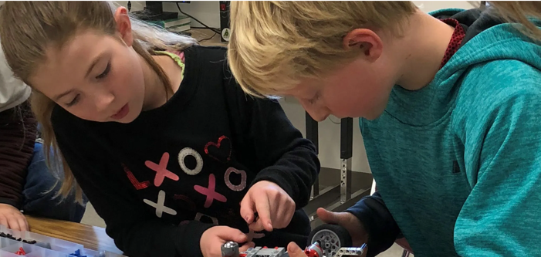
Development Board – our fundraising unit coordinates fundraising for immediate needs of the school and our programs. The funds raised by the Development Board will be used immediately to support the immediate needs of our school. Fundraising programs might include the annual Christmas Tree Drive, the Jog-a-thon, and the Annual Auction. The Development Board works closely with the Foundation Board to help raise funds to support St. Mary’s School.
Endowment fund - refers to the principal investments that are supported by our donors. Endowed funds are held in perpetuity while the interest can either be reinvested into the corpus or be used on an annual basis to support operations of the school.
Foundation Board – our Board that manages the Endowment Fund for St. Mary’s School. The Foundation Board works closely with the Development Board to help raise funds to support St. Mary’s School.
Immediate needs - include purchase of a school bus to bring students on field trips, support of our music and performing arts programs.
Operating expenses – include the ongoing business costs encountered at the school. Those expenses can include salaries of our staff, supplies, utilities and facilities costs, and insurance, etc.
Local investments – our Foundation Board utilizes local vendors to manage our endowment funds from our donors. Those vendors charge a small fee to help manage our portfolios.

If you would like to know more information on how to give or to talk with one of the Foundation’s members, please contact our school or click here to make a donation today:
Sister Margaret Johnson, osu (Secretary to the Foundation Board)
208-301-0293
sisterm@stmarysmoscow.com

or write:
St. Mary’s School Foundation. (need to check this address)
PO Box 8485
Moscow ID 83843-0985
office@stmarysparishmoscow.org

St. Mary's School Foundation
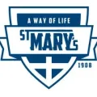
St. Mary's Parish School
Age 3 through Grade 8
412 N Monroe
Moscow, Idaho 83843
Phone: (208) 882-2121
office@stmarysmoscow.com

